American Rescue Plan Act of 2021 Coronavirus State and Local Fiscal Recover Fund

Project Request and Eligibility Determination

BASIC INFORMATION AND DESCRIPTION:
Program/Project Name: | Water Line Extension Project
Program/Project Description: | See Below
Responsible Department: | Water Department
Program/Project Manager Name: | Jane Smith
Total Amount Requested: | $1,200,000
Internal Account Code(s):  (assigned by Finance) | 1234-001
Treasury Expenditure Category Level: | 5 Infrastructure
Treasury Expenditure Category: | 5.11 Drinking water: Transmission & distribution

ELIGIBILITY REVIEW:
Water, Sewer, Stormwater Infrastructure
Please provide description of project and attach any necessary documentation. Must conform with requirements in 31 CFR 35.6(e)(1).

Extension of a water line to a new fire training facility. County will install approximately 7,655 linear feet of 16 inch water main pipe in the Town of TarHeel’s existing water distribution system and connect to existing water mains along Southwest Smith Street. The extension will serve approximately 100 existing residential properties that currently do not have community water, as well as the new fire training facility (to be constructed by 2027). The existing residential property owners rely on wells and have had some issues with contamination. Because the county does not own or operate the water system, after the water line is constructed, the county intends to transfer ownership of the water line at no cost to the Town of TarHeel.

The estimated cost of the water line extension is $1.2 million. The estimate includes engineering, other planning, and construction costs. The water line extension is part of a broader, $15 million project to construct the fire training facility. The remaining costs of the broader project will be paid with non-grant funding sources.

The estimated completion date for the water line extension portion of the project is March 2026. At that point, the town’s water system will be able to connect the 100 residential properties. It expects approximately 50 properties will connect immediately. The fire training facility will not be completed until January 2027. The estimated gross revenues the city will earn from the expected 50 new water customers (including connection fees, new account fees, and average monthly bill revenues) from March 2026 through December 2026 is $100,000.

This project falls within the parameters of EC 5.11. It is eligible for ARP/CSLFRF funding by reference to the EPA’s Drinking Water State Revolving Fund (DWSRF) project list. See 31 CFR Subpart A, Part 35.6(e)(1)(iii). See also “As detailed further below, DWSRF and CWSRF eligible projects continue to be presumed to be necessary investments under the final rule, with the exception of projects for the rehabilitation of dams and reservoirs, which the EPA has permitted in certain circumstances under the DWSRF and, as discussed below, are addressed separately in the final rule.” Final Rule Supplement page 266.

Specifically, it involves the transmission and distribution, including improvements of water pressure or prevention of contamination in infrastructure and lead service line replacements. See page 10 of the DWSRF. [INCLUDE DWSRF PROJECT GUIDE IN PROJECT FILE.]

JUSTIFICATION AND LEGAL REVIEW FOR STATE AUTHORITY:
Project authorized by G.S. 153A, Art. 15, which gives the county authority to construct a water line to serve county citizens.

Transfer to town authorized by G.S. 160A, Art. 20, pursuant to an interlocal government agreement between the county and town.

PROGRAM ADMINISTRATION INFORMATION:
Proposed Project Budget, delineated by Cost Item for Allowable Cost Review. Review conducted in accordance with Allowable Cost Policy.
U.G. Provisions | Cost Items | Estimated Amount | Necessary/  Reasonable | % Allocable | Additional Documentation
200.430 | Compensation |  | Choose an item.
200.431 | Fringe Benefits |  | Choose an item.
200.475 | Travel |  | Choose an item.
200.439 | Equipment & Other Capital | $1,068,000 | Yes | 100% | See procurement policy  Final Rule specifically authorizes this capital project; no further written authorization from Treasury needed
200.453 | Materials & Supplies |  | Choose an item.
200.459 | Consultants / Professional Services  (Engineer) | $82,000 | Yes | 100% | Document qualifications  Document that necessary / more economical to hire consultant than use employees  Contract for services must include description of the service, estimate of time required, rate of compensation, and termination provisions.
200.465 | Occupancy (Rent & Utilities) |  | Choose an item.
200.471 | Telecommunications |  | Choose an item.
200.473 | Training & Education |  | Choose an item.
200.413 (c) | Direct Administrative Costs | $50,000 | Yes | 100% | Inspections done by county personnel; costs based on county inspection fee schedule
 | ADD ADDITIONAL COST ITEMS HERE
 | Total Direct Costs | $1,200,000 | Yes
200.414 | Indirect Costs* | $13,200 | Yes
Total Project Budget |  | $1,213,200
*Indirect costs are calculated as 10% of Modified Total Direct Costs. MTDC means all direct salaries and wages, applicable fringe benefits, materials and supplies, services, travel, and up to the first $25,000 of each subaward (regardless of the period of performance of the subawards under the award). MTDC EXCLUDES equipment, capital expenditures, charges for patient care, rental costs, tuition remission, scholarships and fellowships, participant support

SPECIAL REQUIREMENTS OR LIMITATIONS:
Document any special requirements or limitations that apply to this Expenditure Category and/or project.
All contracts made by a recipient or subrecipient in excess of $100,000 with respect to water, sewer, or broadband infrastructure project that involve employment of mechanics or laborers must include a provision for compliance with certain provisions of the Contract Work Hours and Safety Standards Act, 40 U.S.C. 3702 and 3704, as supplemented by Department of Labor regulations (29 CFR Part 5).
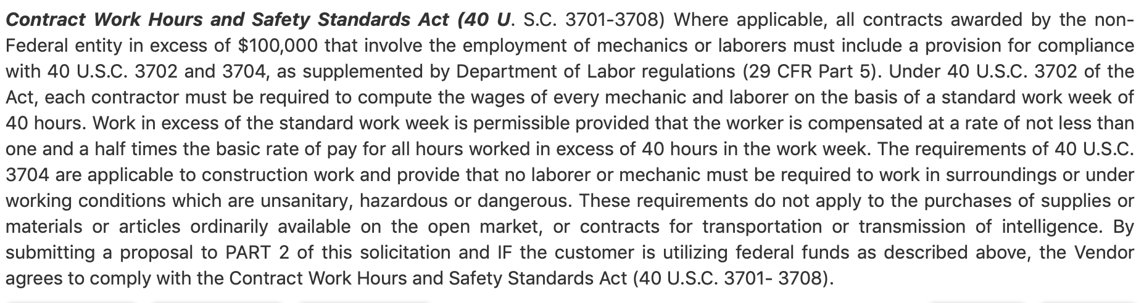
“Project must comply with applicable federal, state, and local law. In the case of infrastructure projects in particular, this includes environmental and permitting laws and regulations. Likewise, as with all capital expenditure projects using SLFRF funds, projects must be undertaken and completed in a manner that is technically sound, meaning that they must meet design and construction methods and use materials that are approved, codified, recognized, fall under standard or acceptable levels of practice, or otherwise are determined to be generally acceptable by the design and construction industry.” Final Rule Supplement page 264.

PROJECT & EXPENDITURE REPORTING DATA ELEMENTS BY EXPENDITURE CATEGORY (EC):
Identify project reporting elements for applicable Expenditure Category (Consult pages 19-34 in the Compliance and Reporting Guide) and ensure that this information is documented as required.
EC | Required Reporting Data Elements | Documented Information?
5.11 | Projected/actual construction start date (month/year)
 | Projected/actual initiation of operations date (month/year)
 | Location Information
 | PWS ID number (Req’d once project starts)
 | Median Household Income of service area (Req’d once project starts)
 | Lowest Quintile Income of service area (Req’d once project starts)
General | FFATA information for all contracts $50K or greater

PROHIBITIONS VERIFICATION:
Conduct preliminary review to determine that project does not violate any of the prohibited terms of the ARP/CSLFRF.
☒ Project does not contravene the statutory purpose of ARP/CSLFRF, including program, service, or capital expenditure that includes a term or condition that undermines efforts to stop the spread of COVID-19
☒ No prohibited Conflict of Interest
☒ Project does not violate applicable state and federal laws and local ordinances
☒ No pension fund deposit
☒ No borrowings or debt service
☒ No financial reserves

APPLICABLE ADDITIONAL UNIFORM GUIDANCE REQUIREMENTS:
Select all that apply to this project and alert appropriate staff for implementation.
☒ Procurement
☒ Property management
☐ Subawards
☒ Program Income
☒ Conflicts of Interest
☒ Records Retention

ADDITIONAL PROJECT NOTES / DIRECTIVES:

ELIGIBLE USE & ALLOWABLE COST REVIEW COMPLETED BY:

________________________________________________ ___________________________________

Signature Date

